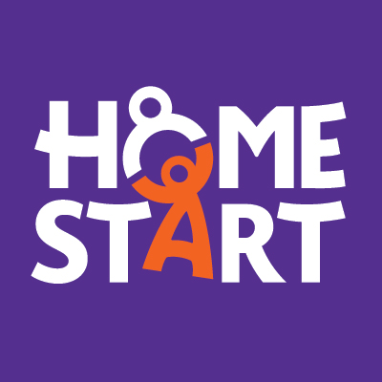




Home-Start Plus- 2025-2026

Home-Start Colchester, Jaywick and Clacton service is delivered across the North East Essex Quadrant (Colchester and Tendring).

Families supported will have needs identified as appropriate for Universal (Level 1) or Additional (Level 2) service provision as identified in the Essex Effective Support Windscreen of need.

Referral form

- Please note that all referrals must be made with the consent of the family. Have you discussed this referral with the family prior to completing this form? YES / NO

- The family must have at least one child under 11

Referred Family Name……………………………… Address……………………………………………………………………………………………………………
………………………………………………………………Postcode …………………………………………
Tel. No …………………………Mobile No …………………..………
E mail ………………………………

Please provide some details about the adults caring for the child[ren]:

 | Name | Main carer √ | Resident in household√ | Date of Birth | Comments
Mother/partner
Father/partner
Other main carer[s]
Other main carer[s]

This project has been designed to offer a mentoring and befriending solution focused service to local families across Colchester and South Tendring. The Home-Start Plus offer is to provide the assistance from another person to offer emotional and practical support.

Referred by: Date of referral:

Name of organisation/Individual

……………………………………………………………………………………………………………….

Email …………………………………………… Phone………………………………………………

Please add any background information that you think we would find useful here, the project leader may get in contact with you for further information.

Are there any Health and Safety issues that we need to consider when making home visits?
…………………………………………………………………………………………………………………………
…………………………………………………………………………………………………………………………

Details of children - Please note the family must have at least one child under the age of 11 years, (please include details of all children under 18)
Child’s name  Youngest first | Gender |  | Date of birth | Immigration status |  |  | Considered to be disabled by main carer? √ if yes | Asian or Asian British |  |  |  | Black or Black British |  |  | Chinese or Other Ethnic Group |  | Mixed | White |  |  | Subject to assessment of needs e.g. CAF/ UNOCINI (√) | Who is the lead professional? | Child in need √ | Child care/ protection plan (√)
Child’s name  Youngest first | Male | Female |  | Asylum seeker | Refugee | Pending | Considered to be disabled by main carer? √ if yes | Indian | Pakistani | Bangladeshi | Other Asian | Caribbean | African | Other | Chinese | Other Ethnic | Any mixed | British | Irish | Other White
C1.
C2.
C3.
C4.
C5.
C6.
C7.
C8
C9
C10.

Please complete those boxes which apply to any of the children
Note: the terms above are nation-specific - not all will be relevant in your area

Needs, | √ | If you have ticked, please tell us how you feel we can help and what other support is currently in place.
Managing child’s behaviour
Support needed with child(ren)’s development
Coping with multiple birth/multiple children
Child under 11 with limited opportunities to participate in community activities
Parent would like to meet other parents in the area.
Parent struggling with mental health effecting ability to cope.
Low income, or short-term aid needed
Conflict in the family
Parenting support
Use of services
Other (please describe)

Details of other members of the household with responsibilities for caring for the children
 | Gender |  | Date of birth | Immigration status |  |  | Consider themselves to be disabled | Asian or Asian British |  |  |  | Black or Black British |  |  | Chinese or Other Ethnic Group |  | Mixed | White
 | Male | Female |  | Asylum seeker | Refugee | Pending | YES? | Indian | Pakistani | Bangladeshi | Other Asian | Caribbean | African | Other | Chinese | Other Ethnic | Any mixed | British | Irish | Other White
Main Carer
Partner living in household

General Data Protection Regulation -If this referral is not signed, then personal data cannot be stored and the referral cannot be accepted.

Consent at the point of referral

A signature is required from the referrer to consent to the personal data on this form being processed by Home-Start.

Referrer…………………………………………………………………

Consent from the Family

Please tick and sign if you are happy to give consent

I I give consent for Home-Start to process the information on this form and store the information on a protected data base and family file.

I give consent to share my information and inform the health visitor or other agency, that they have requested Home-Start support and to share any information with them.

Parents signature……………………………………………………………………………….

Please now return this referral form: If emailing please send the document pass worded to
Office@homestartcjc.co.uk

If posting, please send marked confidential and post to:
Home-Start Colchester The Ark, Jack Andrews Drive, off Gavin Way Colchester Essex CO4 9FF. Tel 01206 854625

Thank you for taking time to provide this information which will help us to process the referral.
We are unable to process your referral until we have received this form. Please return this referral form : Office@homestartcjc.co.uk
Home-Start Colchester, The Ark, Highwoods Methodist Church, Jack Andrews Drive, Colchester, Essex C04 9FF. Tel: 01206 865349

